
LjunggrenAudio RYO Aperture
a Resonant vactrol VCF/LPG/VCA

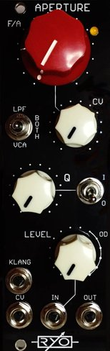

- vactrol LPF / LPG / VCA inspired by the 292 Lowpass Gate of the 1970s Buchla 200 series modular system.
- newly developed and reworked design for eurorack modular synths, based on optocouplers allowing a plucky dynamic response to CV.
- Aperture can be used as a
- Non resonant lowpass filter
- Resonant lowpass filter
- Non resonant lowpass gate
- Resonant lowpass gate
- traditional relatively clean sounding VCA.
- 6dB variety of resonant lowpass gate
- basic manual attenuator
- basic distortion effect with characterful overdriven sound.
- unique "Klang" input generates a decay slope from a trigger,
- input is AC coupled with clipping towards the end of the pot range for overdrive the incoming signal.
- All analogue circuitry.
- Buffered inputs and outputs.
- slim 8HP footprint.
- compact 27mm Depth (with power cable attached).
- low power draw: 50mA +12V / 75mA -12V / 0mA +5V.
- analogue optocouplers used for Non-intrusive voltage control.
- hi-fidelity signal chain with low noise opamps.

downloads
* user manual
* quickstart guide
* assembly guide
* hi-res schematic
* datasheet
* BOM

